

PO Box 28, Singleton NSW 2330

**M** 0427 000 910

**E** [sally@orbitplanning.com.au](mailto:sally@orbitplanning.com.au)

**W** www.orbitplanning.com.au

**ABN** 46 484 735 708

**Planning Proposal**

**(Muswellbrook LEP 2009 Amendment No. 8)**

**Lot 1 DP 323945  
Yarrawa Road, Denman.**

Prepared on behalf of Waebron Pty Ltd

**December 2015 (Revision 4)**

***CONTENTS***

***Page No.***

1. **Introduction 3**
2. **Site Description 3**
3. **The Amending LEP 8**

3.1 Objectives or Intended Outcomes 8

3.2 Explanations of Provisions 8

3.3 Justification 8

* + 1. Section A — Need for the Planning Proposal 8
    2. Section B — Relationship to strategic planning framework 9
    3. Section C — Environmental, social and economic impacts 22
    4. Section D — State and Commonwealth interests 24
  1. Mapping 27
  2. Community Consultation 32
  3. Project Timeline 32

1. **Conclusion 33**
2. **Appendices 31**

Appendix 1 – Extract: Waebron Soil and Land Capability Assessment

Appendix 2 – Gateway Determination

Appendix 3 – Submissions

Appendix 4 – Studies and Investigations

4.1 Preliminary concept lot layout

4.2 Preliminary Aboriginal Heritage Assessment *(attached separately)*

4.3 Preliminary Site Contamination Assessment *(attached separately)*

4.4 Engineering Services Report *(attached separately)*

**1 Intro****duction**

This Planning Proposal has been prepared in accordance with Section 55 of the *Environmental Planning and Assessment Act 1979* and the relevant guidelines published by the NSW Department of Planning & Environment (DP&E), including “A guide to preparing Planning Proposals (October 2012)”.

This Planning Proposal explains the intended effect of the rezoning of Lot 1 DP 323945, Yarrawa Road, Denman for large lot residential purposes, and provides justification for the proposed amendment to Muswellbrook Local Environmental Plan (LEP) 2009.

The Gateway Determination was issued by DP&E on 21 October 2014 (**Appendix 2**). The Gateway conditions required consultation with Department of Primary Industries (Agricultural NSW), Office of Environment and Heritage, Wanaruah Aboriginal Land Council, NSW Resources and Energy and Mines Subsidence Board. The outcomes of community consultation and public authorities consultation are detailed in Section 3 of this report and copies of the submissions are included in **Appendix 3**. A number of specialist studies were commissioned and copies of these studies are included in **Appendix 4**.

At its ordinary meeting held on 9 November 2015, Council considered a report in relation to the above Planning Proposal and resolved that:

*(1). The Department of Planning & Environment be requested to commence legal drafting of the instrument and making of draft Muswellbrook Local Environmental Plan 2009 Amendment No. 08.*

*(2). Council advises the proponent to undertake a comprehensive cultural heritage assessment in consultation with the Wanaruah Local Aboriginal Land Council and Office of Environment and Heritage, following the rezoning process and prior to any future development planning of the site.*

*(3). Prior to commencing legal drafting of the instrument, amend Planning Proposal to identify the subject land as an Urban Release Area.*

In accordance with the above Council resolution, the Planning Proposal has amended to identify Lot 1 DP 323945 as an Urban Release area.

**2 Site D****escription**

The site is legally described as Lot 1 DP 323945 and is located on the southern side of Yarrawa Road Denman. The site contains an area of 41.88 hectares and is irregular in shape. The site slopes from RL140 in the west to RL103 in the east. The site contains an existing dwelling and associated sheds that will be retained on site. There are no easements or restrictions to user on the title. The site is clear of vegetation and does not generally contain any vineyards. The existing dwelling is currently accessed from Yarrawa Road to the north.

The land the subject of this Planning Proposal is owned by Waebron Pty Ltd. Waebron Pty Ltd is a subsidiary of Inglewood Vineyards Pty Ltd, who own and operate the adjoining Two Rivers vineyard and cellar door located to the south and east of the subject site. The Two Rivers vineyard and cellar door are located within the Inglewood Hill and Inglewood Flat land holdings and generally do not extend onto the ‘Waebron’ site as can be see in **Figure 2**. Details of the Inglewood Vineyards Pty Ltd landholding are provided below **Table 1**:

***Table 1:*** *Property details*

|  |  |  |  |  |
| --- | --- | --- | --- | --- |
| **Property** | **Land Ha** | **Parish** | **County** | **Lot /DP Details** |
| Inglewood Hill | 103.2 | Denman | Brisbane | Lot 1 DP 1036050 |
| Inglewood Flat | 38.354 | Denman | Brisbane | Lot 2 DP 1036050 |
| Waebron | 41.88 | Denman | Brisbane | Lot 1 DP 323945 |

Inglewood Vineyards Pty Ltd has valid development consent from Council to operate a commercial winery and associated tourist facilities on the property (DA 91/2000) comprising the following:

* Winery (complete with finished product warehouse and bottling/packaging plant and dry barrel store)
* Restaurant and Cellar Door (capacity 40 dining guest and 20 non-dining guests)
* 20 x 4 person tourist cabins

The commercial winery component of the development is no longer required as a long-term commercial agreement is in place for wine production off site. The commercial winery operation was approved by Council for location on the ‘Weabron’ property as the soils have low fertility and minimal rural land capability. This land is not used for grape growing (apart from a small area in the western portion of the site comprising less than 1 hectare) and is not used for agricultural production. A soil and land capability assessment of the site was undertaken as part of the development application for the winery. This assessment identified, pursuant to the Soil Conservation Service’s Rural Land Capability system, that Waebron comprised Class IV land, which is defined as being best suited for grazing with occasional cultivation only as it would not be stable with continuous cultivation. The assessment also identified that the river flats of the adjoining Two Rivers contains Class I land, which is land suitable for regular cultivation with no constraints. The sloping areas of Two Rivers were identified as Class IV land, however, it was noted that protection from erosion has been provided by extensive soil conservation measures, including contour banks, grassed waterways, contour planting of vines and “sod culture”. The growing of grapes was deemed to be certainly sustainable on Class I land and also on the Class IV land on the slopes, provided Two Rivers continued to employ the extensive management practices. Details of the soil and land capability assessment are provided in **Appendix 1** to this report.

The Waebron land does not have a history of use for prime agricultural land and is not currently suitable for grape growing. Given the proximity of the land to the Village of Denman, the use of the land for large lot housing purposes is considered to be preferred over the sites possible agricultural uses, a position supported by NSW Department of Primary Industries in their consultation response.

Two Rivers are a long-term member of the Denman community and a major tourism generator for the Upper Hunter Valley. Two Rivers has won multiple awards for their wines since starting their business in 1988, the latest being a Gold Medal from the Hunter Valley Wine Show August 2014. Two Rivers have a cellar door and a single guest cottage, both of which are popular tourist attractions for Denman. The owners are committed to improving the tourist facilities available on the Two Rivers site and are keen to proceed with the approved tourism accommodation, which has been economically unviable to date. The owners see the potential for the rezoning of Waebron to generate the much needed capital to fund the approved tourism facilities at Two Rivers. The rezoning and development of Waebron, given its limited agricultural capacity, proximity to existing services and unique scenic attributes provides an opportunity for the owners to reinvest in the long-term future of their viticulture business and cement Two Rivers as a major tourist destination for the Upper Hunter.

**Figure 1** illustrates a locality plan of the subject site and surrounding area.

**Figure 2** provides an aerial view of the site and surrounds.

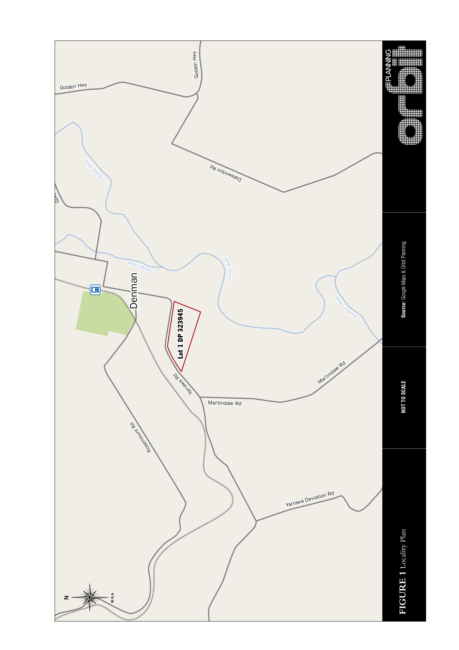

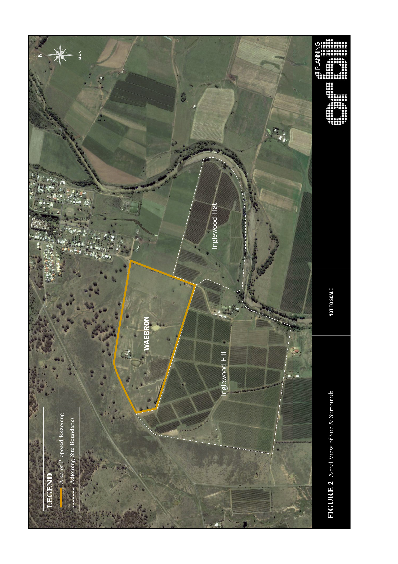**3 The A****mending LEP**

The following matters address the requirements of a Planning Proposal as detailed in the Department of Planning & Infrastructure “A guide to preparing Planning Proposals (October 2012)”.

**3.1 Objectives** **or Intended Outcomes**

The Planning Proposal intends to amend Muswellbrook Local Environmental Plan (LEP) 2009 by rezoning Lot 1 DP 323945 to enable the land to be developed for large lot residential living purposes.

**3.2 Explana****tion of Provisions**

To achieve the objectives of this Planning Proposal, it is intended to make the following amendments to Muswellbrook LEP 2009:

* Amend Land Zoning Map (LZN_005 and LZN_005B) by rezoning Lot 1 DP 323945 from RU1 Primary Production to R5 Large Lot Residential as shown in Part 3.4 MAP A.
* Amend Lot Size Map (LSZ_005 and LSZ_005B) to reflect minimum lot size as 4000m2 as shown in Part 3.4 MAP B.
* Amend Height of Building Map (HOB_005 and HOB_005B) to reflect a maximum height of 8.5 metres as shown in Part 3.4 MAP C.
* Amend Urban Release Area Map (URA_005 and URA_005A) to identify Lot 1 DP 323945 as an Urban Release Area as shown in Part 3.4 MAP D.

**3.3 Jus****tification**

**3.3.1 Section A — Ne****ed for the Planning Proposal**

***Is the Planning Proposal a result of any strategic study or report?***

On 10 March 2014 Muswellbrook Shire Council adopted the Muswellbrook Residential and Rural Residential Strategy (MRRRS). The following key findings of the MRRRS are highlighted, as they relate to Weabron:

* The MRRRS identifies Weabron (referred to as Candidate Area A) as the preferred candidate area for rural residential development in Denman, being the least constrained both environmentally and from an infrastructure servicing perspectives.
* The MRRRS nominates Waebron as ‘Category 1’ land which is defined as *“land that is a logical extension of and located in close proximity to existing developed areas, building upon existing services and amenities and requires the augmentation of infrastructure”*. The MRRRS requires that Category 1 land may be investigated in the short term and must be rezoned prior to any investigation of Category 2 land.
* The MRRRS provides for Weabron to be rezoned to R5 with land to be released within the short term (2016-2021) to ensure adequate supply and contestability in the market.

It is considered that the rezoning of Waebron from RU1 Primary Production to R5 Large Lot Residential is consistent with the findings of the Council adopted MRRRS. The Planning Proposal provides sufficient grounds on which to support the proposed rezoning of the land for large lot residential purposes.

***Is the Planning Proposal the best means of achieving the objectives or intended outcome, or is there a better way?***

The subject site is currently zoned RU1 Primary Production with a minimum lot size of 80ha by the Muswellbrook LEP 2009. Subdivision for large lot residential purposes cannot be achieved without amending the LEP. The proposed Planning Proposal is considered to be the best means of achieving the rezoning of Waebron for large lot residential purposes.

**3.3.2 Sectio****n B — Relationship to strategic planning framework**

***Is the Planning Proposal consistent with the objectives and actions contained within the applicable regional or sub regional strategy?***

**Chapter 3** of the Upper Hunter SRLUP identifies the subject site as being mapped at the regional level as a Critical Industry Cluster for Equine and Viticulture. It is noted that the mapping of strategic agricultural land indicates broadly where is occurs throughout the region and that half of the Denman Village is mapped as containing CIC Equine and Viticulture. The Upper Hunter SRLUP states that the mapping is at a regional scale and is not intended to be used for property level interpretations. The subject site has no history of equine use and although it adjoins the Two Rivers vineyard, the land itself does not form part of the agricultural land used for grape production, as detailed in Section 2 of this report.

Chapter 3 Table 1 of Upper Hunter SRLUP (Page 21) provides that critical industry clusters must meet the following criteria:

* *There is a concentration of enterprises that provides clear development and marketing advantages and is based on an agricultural product;*
* *The productive industry are interrelated;*
* *It consists of a unique combination of factors such as location, infrastructure, heritage and natural resources;*
* *It is of national and/or international importance;*
* *It is an iconic industry that contributes to the region’s identity; and*
* *it is potentially substantially impacted by coal seam gas or mining proposals.*

In addition to this criteria the Upper Hunter SRLUP (page 22) states:

‘*The critical industry cluster (CIC) criteria included in Table 1 ensures socio-economic values are appropriately considered in the strategic agricultural land mapping. A CIC is a localised concentration of interrelated productive industries based on an agricultural product that provides significant employment opportunities and contributes to the identity of the region. The cluster also needs to be potentially substantially impacted by coal seams gas or mining proposals. Based on this definition an equine cluster around Scone, Bylong and Denman and a viticulture cluster around Broke, Pokolbin and Denman have been identified as strategic agricultural lands’*

It is apparent that the objectives and actions of Chapter 3 of the Upper Hunter SRLUP seek to balance the conflicting demands of the agriculture and resource industries and ensure that strategic agriculture land and Critical Industry Clusters are not impacted by intrusive mining or coal seam gas developments. The objectives of Chapter 3 are:

* *Ensure protection of strategic agricultural land and the water resources it relies on;*
* *Ensure security and clarity for agriculture and mining and coal seam gas industries*
* *Ensure a balanced use of land by competing industries*
* *Provide enhance future opportunities for sustainable mining and agricultural industries*

The Planning Proposal is not inconsistent with the Chapter 3 objectives as the proposed rezoning of the site for large lot residential purposes does not affect prime agricultural land and the proposed use can be developed without conflict to the neighbouring Two Rivers vineyard and without impacting on the future of the adjoining CIC Viticulture land. Consideration has also been given to the Actions under Chapter 3 of Upper Hunter SRLUP and it is submitted that the Planning Proposal is not inconsistent with Action 3.3, as the rezoning of rural land for large lot residential housing purposes does not threaten strategic agricultural land or the mapped Critical Industry Cluster of the Viticulture or Equine industries.

The broader themes for land use compatibility and the sites agricultural capability identified by DP&E have also been considered and it is noted that the owner of the land and proponent of this Planning Proposal also owns and runs the adjoining Two Rivers Vineyard. As discussed in Section 2 the land the subject of the application has not historically been used for commercial grape growing, or has any history of equine use. This parcel of land has been identified for many years as unsuitable for the growing of commercial vines and was designated by the owners for non-prime agricultural land uses, evidenced by the development consent granted by Council for a winery and associated product warehouse, bottling/packaging plant and dry barrel storage facility on site. The need for an on site winery has passed and there are now long term contracts in place for wine making off site which render this parcel of land surplus to the agricultural needs of the adjoining Two Rivers Vineyard.

The future design of the large lot residential housing development will incorporate appropriate setbacks and buffers to ensure there will be no land use conflict between the housing and viticultural uses. A concept lot layout has been prepared to demonstrate such buffer distances can be achieved between the neighbouring properties. It is noted that this layout is indicative only and an alterative plan may be developed in the future subject to further design considerations. There are numerous successful examples where housing and vineyards can co-exist and having the one owner designing and developing both land uses means that the opportunity for land use conflict will be negligible and managed in the long term. The proposed rezoning and use of the site for large lot residential purposes is compatible with the Critical Industry Cluster Viticulture and is consistent with the Upper Hunter SRLUP.

**Chapter 4** of Upper Hunter SRLUP relates to Infrastructure Provision and the objectives are:

* *Ensure sufficient infrastructure provision to carer for sustainable economic and population growth in the region;*
* *Ensure a balanced approach to infrastructure provision across all key industries, in particular to ensure that infrastructure growth to support the coal and coal seam gas industries does not adversely impact upon agriculture.*

The site the subject of this Planning Proposal is located on the edge of Denman township close to all existing services and there are no major impediments to infrastructure servicing of the site, as discussed elsewhere in this report and demonstrated by the Engineering Services Report prepared by RHM Engineers and provided in **Appendix 4** to this report. . Consideration has also been given to the Actions under Chapter 4 of Upper Hunter SRLUP and it is submitted that the Planning Proposal is consistent with Action 4.3, as the site is for future housing and can be adequately serviced.

**Chapter 5** of Upper Hunter SRLUP relates to Economic Development and Employment and the objectives are:

* *Ensure an adequate supply of land for the needs of Upper Hunter industries;*
* *Ensure an adequate supply of labour for the needs of Upper Hunter industries;*
* *Diversify the region’s economy and build economic resilience;*
* *Build cohesive and liveable communities by addressing conflicts in demand for resources and improving access to employment and training.*

As highlighted earlier in this report, Two Rivers are a long-term member of the Denman community and a major tourism generator for the Upper Hunter Valley. Two Rivers has won multiple awards for their wines since starting their business in 1988, the latest being a Gold Medal from the Hunter Valley Wine Show August 2014. Two Rivers have a cellar door and a single guest cottage, both of which are popular tourist attractions for Denman. The owners are committed to improving the tourist facilities available on the Two Rivers site and are keen to proceed with the approved tourism accommodation, which has been economically unviable to date. The owners see the potential for the rezoning of Waebron to generate the much needed capital to fund the approved tourism facilities at Two Rivers. The rezoning and development of the site, given its limited agricultural capacity, proximity to existing services and unique scenic attributes provides an opportunity for the owners to reinvest in the long-term future of their viticulture business and cement Two Rivers as a major tourist destination for the Upper Hunter. It is submitted that this potential viticulture tourism investment for Two Rivers is consistent with the objectives Chapter 5 of Upper Hunter SRLUP, which aim to diversity the region’s economy and build economic resilience.

**Chapter 6** relates to Housing and Settlement and the objectives state:

* *Ensure an adequate supply of housing to meet community needs;*
* *Ensure a greater diversity of housing types, including smaller housing types, rental housing and temporary housing;*
* *Improve the supply and range of affordable housing;*
* *Building cohesive and liveable communities by ensuring towns and villages are well designed, liveable and provide a range of housing types.*

In relation to rural residential and lifestyle housing Chapter 6 of the Plan states the following:

*Rural residential and lifestyle housing is a popular housing choice throughout the region. This type of housing normally occurs around urban settlements and, if located appropriately, can contribute to the character, economy and social fabric of communities. If inappropriately located it can create problems such as land use conflict with other rural land uses, loss or alienation of valuable agricultural lands, social isolation for residents, an increase in the cost of providing local services and facilities and adversely impact on the environment. Rural residential and lifestyle housing growth should occur in close proximity to existing centres, towns and villages and is to be consistent with the settlement planning principles identified below with regard to residential lands.*

Consideration has also been given to the Planning Proposal’s consistency with the Settlement Planning Principles within the UHSRLUP, as detailed in **Table 2** below. The comments in Table 2 below reference the findings that are included in the Council adopted MRRRS.

***Table 2:*** *The Settlement Planning Principles in the Upper Hunter Strategic Regional Land Use Plan 2012*

| **Settlement Planning Principle** | **Comment** | **Compliance** |
| --- | --- | --- |
| Development will contribute to the diversity of housing types available. Any medium or higher density housing should be located in central and accessible locations to ensure access to a full range of services within a reasonable walking distance. | The MRRRS highlights there is currently no new rural residential land available for sale in Denman and support for the rezoning of Weabron will improve the diversity of housing choices for Denman. The site is located on the edge of the existing Denman Village with all local services within walking distance. | YES |
| Development will be located to maximise the efficiency of essential urban infrastructure, services and facilities, including transport, health and education | The MRRRS identifies the Waebron site as the preferred sequenced candidate area for Denman and clearly states there are no infrastructure impediments to development. The Engineering Services Report provided in **Appendix 4** confirms this position. The site is strategically positioned on the edge of Denman township close to all existing services. Consideration of services availability within the MRRRS (see MRRRS Appendix 4) identified no constraints for Waebron. For water an extension of the existing service is required. For sewer, connection to the existing network is available, although not necessarily required. For roads an extension of the local road network would be provided to access the development. For stormwater a detailed design will be undertaken at the future development stage, which would ensure no localised flooding impacts. Being located on the edge of the existing village the site has good access to the existing town centre and the education and health facilities contained therein. | YES |
| Development will respect and respond to the character of the area and the identified settlement hierarchy of the region. | The MRRRS has nominated Waebron as the preferred candidate area for rural residential development in Denman and the quality of the development will respond to the unique scenic attributes of the site. The Planning Proposal seeks to provide a unique large lot residential living estate associated with the award winning Two Rivers vineyard and tourism operation. This type of residential land is not currently available in Denman as highlighted in the MRRRS, and is not foreshadowed in any future release areas. The land is relatively constraint free and is in close proximity to services and can be developed in a timely manner. | YES |
| New residential areas will be planned with streets that make it easy for people to walk and cycle and with recreational and open space. | Suitable consideration will be given to the provision of open space and recreation at development design stage, including the potential of the site to be involved in the Muswellbrook Shire Council’s Stepping Stones Project, which seeks to strengthen habitat connectivity enabling species movement across the Hunter Valley. The site is within walking distance of existing open space areas within Denman Village. | YES |
| New residential and rural residential areas will respect environmental and cultural heritage and avoid areas most affected by natural hazards or having high cultural significance. | As highlighted in the MRRRS, the site is not identified as containing any environmental constraints in relation to ecology, bushfire or flooding. A Preliminary Aboriginal Assessment has been undertaken and is provided in **Appendix 4.** The Due Diligence Assessment identified 44 Aboriginal Artefacts on site, all of which were found in exposed areas. The proposed rezoning will not have any impact on these items. The Assessment recommends that prior to the commencement of any future approved development of the land further comprehensive archaeological assessment in accordance with OEH requirements be undertaken. This approach is consistent with OEH guidelines. | YES |
| New residential and rural residential areas should minimise the potential for land use conflict with land needed for valuable economic activities, such as valuable agricultural lands and natural resource lands. This includes avoiding locations where possible adverse impacts associated with industry (such as noise, dust, visual impacts or other amenity impacts) are likely to affect future residents. | The site is well positioned to avoid major land use conflicts being at the edge of the Denman Village. The LEP will be compatible with the surrounding village and rural land. The adjoining Two Rivers operation will be managed to ensure there is no potential for land use conflict between the large lot residential properties and existing vineyards.  A small portion of the north east corner of the site (approximately 1000m2) is within the Denman Sewerage Treatment Plant 400m buffer as detailed in Section 22 of Muswellbrook Shire Council Development Control Plan. The small area of the site affected by this buffer can be omitted from containing any housing in the final subdivision layout design.  The site also contains land identified in the Upper Hunter Strategic Regional Land Use Plan, as being partially within the Critical Industry Cluster Land (Vineyards) and Critical Industry Cluster Land (Equine). As discussed in Section 2 of this proposal the land the subject land contains soil of low fertility and minimal rural land capability. Waebron adjoins the more fertile soil that comprises the Two Rivers Vineyard and there will no change to the viticultural production of the adjoining land. There is no known history of equine land use on the Weabron site or adjoining vineyards. The proposed rezoning and use of the land for large lot housing purposes is a compatible use with the Two Rivers Vineyard and surrounding agricultural land and Denman Village and it is not considered to be inconsistent with the provisions of the Upper Hunter Strategic Regional Land Use Plan and will not create a land use conflict with agricultural or natural resource lands.  As highlighted in the MRRRS the Waebron site is not constrained by any land use conflicts and is the preferred site for future rural residential development in Denman. Consideration will be given to minimising potential land use conflicts at the subdivision design stage. | YES |
| New rural residential areas should be located adjacent to, or in close proximity to, existing urban centres and be within easy access of relevant infrastructure and services. | As highlighted in the MRRRS and discussed above the Waebron site is located within close proximity of the existing town centre of Denman and is within access of existing infrastructure and services. The inclusion of Lot 1 as an Urban Release Area will ensure that any public utility infrastructure that is essential for the proposed development is available or that adequate arrangements have been made to make that infrastructure available when required. | YES |

It is submitted that the Planning Proposal is consistent with the relevant objectives and actions as highlighted above and detailed in the Upper Hunter SRLUP.

***Is the Planning Proposal consistent with a council’s local strategy or other local strategic plan?***

As discussed in Section 3.3.1, Weabron site is nominated within the Council adopted MRRRS as the preferred candidate area for rural residential development in Denman.

The following key findings of the MRRRS are noted, as they relate to Denman:

* Muswellbrook and Denman townships are distinct sub markets, with little overlap in demand, and the Denman sub market accounts for around 10% of the total residential and rural residential demand in the LGA.
* The local and regional policies indicate that new residential and rural residential area should be located near existing residential areas to minimise the potential for land use conflict and maximise the efficiency of infrastructure usage.
* The MRRRS notes that evidence suggests there is strong underlying demand for housing in Denman that is not currently being met by supply, which accounts for the increase in prices for housing in Denman.
* The supply assessment revealed that the Waebron site (referred to as Candidate Area A in MRRRS) has no environmental constraints to development and is the only candidate area in Denman to achieve this status; The supply assessment revealed that the Waebron site is the least constrained candidate area for infrastructure provision, with an extension to the water available with no major upgrade required, sewer servicing available (although not necessarily required), and road extension and stormwater provision feasible.
* The supply assessment revealed that the Waebron property is the least constrained site overall for Denman when the environmental and infrastructure constraints were considered together.
* The supply assessment highlights the importance of having contestability in the market and notes that there is currently no new rural residential land for sale in Denman.
* Having regard to the above findings the MRRRS concludes that there is justification in releasing additional rural residential supply for Denman, and nominates the Waebron site as the preferred candidate area.

The following recommendations of the MRRRS are noted, as they relate to Denman:

* Candidate Area A (Waebron) is number one in the preferred sequencing for future rural residential housing in Denman.
* In relation to timing for new releases (Denman) the MRRRS recommends additional land should be released in the short term to address the constraints to larger lot yield.
* The following specific comments are noted in the recommendations of the MRRRS as they relate to rural residential housing in Denman:

*‘There is currently no new rural residential land available for sale in Denman. There is no indication that landowners in the established area are interested in further subdivision of their land in Denman. Further, the timing and number of available rural residential type lots within the West Denman release area is also uncertain. Similarly, there is no guarantee that the estimated full lot yield will be released in the short term as the proposed rural residential type lots (zoned as RU5 Village) are contained in later stages of the West Denman release area. From this perspective, and given the imperative to ensure contestability in the market, at least one additional development front or new developer should be contemplated in short term. Any new development should be sequential and impose no net cost to Council or the state government.’*

It is clear from the MRRRS that the land the subject of this Planning Proposal is the preferred candidate area for future rural residential housing in Denman and that there is strategic justification and support for the release of the land in the short term. The recommendations of the MRRRS, as they relate to Denman, can be achieved through support of this Planning Proposal.

**Community Strategic Plan 2013-2023**

The Planning Proposal is consistent with Council’s Community Strategic Plan 2013-2023 and the following strategies are particularly relevant to this proposal:

* Plan for a diverse range of housing types which meet the changing needs of the community.
* Provide sufficient serviced land for residential purposes.

***Is the Planning Proposal consistent with applicable State Environmental Planning Policies (SEPP)?***

An assessment of relevant SEPPs against the Planning Proposal is provided in **Table 3** below.

***Table 3****: Assessment of relevant State Environmental Planning Policies*

| **SEPP** | **RELEVANCE** | **CONSISTENCY AND IMPLICATIONS** |
| --- | --- | --- |
| SEPP 1 — Development Standards | The SEPP makes development standards more flexible. It allows councils to approve a development proposal that does not comply with a set standard where this can be shown to be unreasonable or unnecessary. | This does not apply to the Muswellbrook LGA as per Clause 1.9 (2) of the MLEP 2009. |
| SEPP 21 — Caravan Parks | The SEPP provides for development for caravan parks. | Nothing in this Planning Proposal affects the aims and provisions of this SEPP. |
| SEPP 30 — Intensive Agriculture | The SEPP provides considerations for consent for intensive agriculture. | Nothing in this Planning Proposal affects the aims and provisions of this SEPP. |
| SEPP 32 — Urban Consolidation (Redevelopment of Urban Land) | The SEPP makes provision for the redevelopment of urban land suitable for multi-unit housing and related development. | Nothing in this Planning Proposal affects the aims and provisions of this SEPP. |
| SEPP 33 — Hazardous and Offensive Development | The SEPP provides considerations for consent for hazardous & offensive development. | Nothing in this Planning Proposal affects the aims and provisions of this SEPP. |
| SEPP 44 — Koala Habitat Protection | This SEPP applies to land across NSW that is greater than 1 hectare and is not a National Park or Forestry Reserve. The SEPP encourages the conservation and management of natural vegetation areas that provide habitat for koalas to ensure permanent free-living populations will be maintained over their present range. | Nothing in this Planning Proposal affects the aims and provisions of this SEPP. |
| SEPP 55 — Remediation of Land | This SEPP applies to land across NSW and states that land must not be developed if it is unsuitable for a proposed use because of contamination. | An Environmental Site Assessment 2015 (**Appendix 4**) indicated that potentially contaminating activities were limited to pesticide and herbicide use associated with grape growing, possible fertiliser use, some livestock aggregation areas and possible petrol or diesel water pump.  Zinc, Boron and Copper were measured in concentrations in excess of the ecological criteria but well within human health criteria. The assessment recommended that the site has been adequately characterised and is suitable for the proposed change in land use. |
| SEPP 64 — Advertising and Signage | The SEPP aims to ensure that outdoor advertising is compatible with the desired amenity and visual character of an area, provides effective communication in suitable locations and is of high quality design and finish. | Nothing in this Planning Proposal affects the aims and provisions of this SEPP. |
| SEPP 65 — Design Quality of Residential Flat Development | The SEPP relates to residential flat development across the state through the application of a series of design principles. Provides for the establishment of Design Review Panels to provide independent expert advice to councils on the merit of residential flat development. | Nothing in this Planning Proposal affects the aims and provisions of this SEPP. |
| Housing for Seniors or People with a Disability 2004 | The SEPP aims to encourage provision of housing for seniors, including residential care facilities. The SEPP provides development standards. | Nothing in this Planning Proposal affects the aims and provisions of this SEPP. |
| Building Sustainability Index: BASIX 2004 | The SEPP provides for the implementation of BASIX throughout the State. | Nothing in this Planning Proposal affects the aims and provisions of this SEPP. |
| Mining, Petroleum Production & Extractive Industries 2007 | The SEPP aims to provide proper management of mineral, petroleum and extractive material resources and ESD. | The site is located within mine subsidence district and future approval would be required for subdivision by Mine Subsidence Board. Given the proximity of the site to the existing Denman Village it is considered highly unlikely that the land would be suitable for mining purposes.  The Mine Subsidence Board were consulted and they have no objection to the proposed rezoning, a copy of their submission is included in **Appendix 3.** NSW Trade & Investment (Resources and Energy) were also consulted and although they initially raised some concern, on review of the full details of the proposal they advised they have no objection to the proposed rezoning. Copies of the submissions from NSW Trade & Investment (Resources and Energy) are provided in **Appendix 3.** |
| Major Development 2005 | The SEPP defines certain developments that are major projects to be assessed under Part 3A of the Environmental Planning and Assessment Act 1979 and determined by the Minister for Planning. It also provides planning provisions for State significant sites. In addition, the SEPP identifies the council consent authority functions that may be carried out by Joint Regional Planning Panels (JRPPs) and classes of regional development to be determined by JRPPs. | Nothing in this Planning Proposal affects the aims and provisions of this SEPP. |
| Infrastructure 2007 | The SEPP provides a consistent approach for infrastructure and the provision of services across NSW, and to support greater efficiency in the location of infrastructure and service facilities. | The inclusion of Lot 1 as an Urban Release Area will ensure that any public utility infrastructure that is essential for the proposed development is available or that adequate arrangements have been made to make that infrastructure available when required. It is not proposed to include any provisions, which would be inconsistent with the SEPP. |
| Rural Lands 2008 | The SEPP aims to facilitate economic use and development of rural lands, reduce land use conflicts and provides development principles. | The proposal seeks to rezone the land from RU1 Primary Production to R5 Large Lot Residential. The rezoning will result in the loss of a small portion of land zoned for rural purposes. It is noted that the land the subject of this proposal has lower fertility and minimum rural land capability as discussed in Section 2.  The rezoning and future development of the land will be undertaken by the owner of the adjoining Two Rivers vineyard, ensuring that adequate buffer zones and setbacks are adopted to avoid any land use conflict. The rezoning of the site for large lot housing purposes is not an incompatible land use with the adjoining vineyards and the land can be developed without adversely impacting on the agricultural productivity of this established viticultural business.  The development of the land for low density rural residential housing purposes is a compatible land use with the adjoining Two Rivers vineyard, which is a thriving and productive viticultural business. The owners of Two Rivers are committed commercial wine makers and they will not jeopardise the long-term economic future of commercial viticulture by proposing or developing an incompatible land use.  In this context, the proposed changes under this Planning Proposal are considered of minor significance and are considered to be consistent with the intent of this SEPP.  NSW Department of Primary Industries (NSW Agriculture) was consulted upfront and DPI indicated their support to proposed rezoning on the grounds of MRRRS. |
| Exempt and Complying Development Codes 2008 | The SEPP provides exempt and complying development codes that have State-wide application, identifying, in the General Exempt Development Code, types of development that are of minimal environmental impact that may be carried out without the need for development consent; and, in the General Housing Code, types of complying development that may be carried out in accordance with a complying development certificate. | Additional and supporting information to the MLEP 2009. Nothing in this Planning Proposal affects the aims and provisions of this SEPP. |
| Affordable Rental Housing 2009 | The SEPP provides for an increase in the supply and diversity of affordable rental and social housing in NSW. | Nothing in this Planning Proposal affects the aims and provisions of this SEPP |

***Is the Planning Proposal consistent with applicable Ministerial Directions (s.117 Directions)?***

An assessment of relevant S117 Directions against the Planning Proposal is provided in the **Table 4** below.

***Table 4****: Assessment of relevant S117 Directions*

| **DIRECTIONS** | **AIM OF DIRECTION** | **CONSISTENCY AND IMPLICATIONS** |
| --- | --- | --- |
| **1 — Employment and Resources** | | |
| 1.1 Business and Industrial Zones | Encourage employment growth in suitable locations, protect employment land in business and industrial zones, and support the viability of identified strategic centres. | Planning Proposal not affected by this direction. |
| 1.2 Rural Zones | The objective of this direction is to protect the agricultural production value of rural land. | This proposal seeks to rezone the land from RU1 Primary Production to R5 Large Lot Residential. The Planning Proposal is consistent with the recommendations of the local strategy MRRRS adopted by Muswellbrook Shire Council. NSW Department of Primary Industries (NSW Agriculture) have advised they have no objection to the proposed rezoning and supported it on the grounds of MRRRS.  As highlighted by the soil and land capability assessment previously undertaken for the site and included in **Appendix 1** to this report, the land the subject of this application is Class IV land and the site does not have a history of agricultural use. The land has not historically been used for viticultural purposes and was identified early on as not being of sufficient agricultural quality to be used for commercial viticultural purposes. The use of the land for large lot housing purposes is not inconsistent with the Class IV land classification and will not reduce the amount of productive agricultural land used by the adjoining Two Rivers vineyard.  The rezoning and future development of the land will be undertaken by the owner of the adjoining Two Rivers vineyard, ensuring that adequate buffer zones and setbacks are adopted to avoid any land use conflict. A concept layout plan reinforces this is achievable on site. The rezoning of the site for large lot housing purposes is not an incompatible land use with the adjoining vineyards and the land can be developed without adversely impacting on the agricultural productivity of this established viticultural business.  The development of the land for low density rural residential housing purposes is a compatible land use with the adjoining Two Rivers vineyard, which is a thriving and productive viticultural business. The owners of Two Rivers are committed commercial wine makers and they will not jeopardise the long term economic future of commercial viticulture by proposing or developing an incompatible land use. The use of the site for rural residential housing purposes, designed to be compatible with the adjoining vineyard lands is consistent with objective of Direction 1.2. |
| 1.3 Mining, Petroleum Production and Extractive Industries | The objective of this direction is to ensure that the future extraction of State or regionally significant reserves coal, other minerals, petroleum and extractive materials is not compromised by inappropriate development. | This Planning Proposal will rezone the land to R5 Large Lot Residential, which does not permit extractive industries. Given the proximity of the site to the existing Denman Village and the established Two Rivers Vineyard, it is clear that the site would not be deemed suitable for future mining. A position reinforced by NSW Trade & Investment (Resources & Energy) advice provided in **Appendix 3.**The site has been identified in the adopted MRRRS as the preferred candidate area of rural residential housing, and the proposal is not viewed as restricting the potential development of resources of coal or other extractive materials which are of State or regional significance. The Planning Proposal is considered to be consistent with the intent of this direction. |
| 1.5 Rural Lands | The objective of this direction is to protect the agricultural production value of rural land and facilitate the economic development of rural lands for rural related purposes. | This proposal seeks to rezone the land from RU1 Primary Production to R5 Large Lot Residential. The Planning Proposal is consistent with the recommendations of the local strategy MRRRS adopted by Muswellbrook Shire Council.  As highlighted by the soil and land capability assessment previously undertaken for the site and included in **Appendix 1** to this report, the land the subject of this application is Class IV land and does not have a history of agricultural use. The land has not historically been used for viticultural purposes and was identified early on as not being of sufficient agricultural quality to be used for commercial viticultural purposes. The use of the land for large lot housing purposes is not inconsistent with the Class IV land classification and will not reduce the amount of productive agricultural land used by the adjoining Two Rivers vineyard. The rezoning and future development of the land will be undertaken by the owner of the adjoining Two Rivers vineyard ensuring that adequate buffer zones and setbacks are adopted to avoid any land use conflict. The rezoning of the site for large lot housing purposes is not an incompatible land use with the adjoining vineyards and the land can be developed without adversely impacting on the agricultural productivity of this established viticultural business.  The development of the land for low density rural residential housing purposes is a compatible land use with the adjoining Two Rivers vineyard, which is a thriving and productive viticultural business. The owners of Two Rivers are committed commercial wine makers and they will not jeopardise the long term economic future of commercial viticulture by proposing or developing an incompatible land use. The use of the site for rural residential housing purposes, designed to be compatible with the adjoining vineyard lands is consistent with objective of Direction 1.5.  Furthermore, support for this proposal would provide large lot housing at the edge of Denman Village and within close proximity to existing services meaning that other rural land more remote from services and potentially of larger size and better agricultural quality is not taken up for this purpose. In addition, it is noted that the rezoning and future development of the site for large lot housing purposes has the potential to generate income for Two Rivers which will assist in pursuing the substantial tourism development that has been approved at the Two Rivers vineyard. It is submitted that this is consistent with the objective (b) of Direction 1.5, which seeks to facilitate the orderly and economic development of rural land for rural and related purposes. |
| **2 — Environment and Heritage** | | |
| 2.1 Environment Protection Zones | The objective of this direction is to protect and conserve environmentally sensitive areas. | The land is not identified as an environmental protection zone, and it is unlikely the site would be considered environmentally sensitive. The site is largely clear of vegetation and the potential loss of vegetation as a result of future development of the land for large lot residential purpose would be of minor significance and would not be contrary to this direction. The Planning Proposal is considered to be consistent with the intent of this direction. |
| 2.3 Heritage Conservation | The objective of this direction is to conserve items, areas, objects and places of environmental heritage significance and indigenous heritage significance. | There has been a previous Aboriginal site investigation that identified some isolated sites and these have been registered with AHIMS. Consultation with OEH in December 2014 recommended, given the time lapsed since the previous assessment that a Due Diligence Assessment be undertaken to establish what is currently on site. This assessment found 44 artefacts, all of which were found in exposed areas. The proposed rezoning will not have any impact on these items.  The Heritage Assessment recommends that prior to the commencement of any future approved development of the land further in-depth archaeological assessment in accordance with OEH requirements be undertaken. This further assessment would include consultation with stakeholders, including the Wanaruah Local Aboriginal Land Council. Every effort would be made to avoid disturbance of any Aboriginal sites, however where unavoidable appropriative management strategies will be developed in consultation with the local Aboriginal community. |
| 2.4 Recreation Vehicle Areas | The draft LEP amendment does not enable land to be developed for the purpose of a recreation vehicle area (within the meaning of the Recreation Vehicles Act 1983). | Planning Proposal not affected by this direction. |
| **3 — Housing, Infrastructure and Urban Development** | | |
| 3.1 Residential Zones | Encourage a variety and choice of housing types to provide for existing and future housing needs, make efficient use of existing infrastructure and services and ensure that new housing has appropriate access to infrastructure and services, and minimise the impact of residential development on the environment and resource lands. | The proposal seeks to rezone the land to R5 Large Lot Residential. The Planning Proposal is consistent with the recommendations of the local strategy MRRRS adopted by Muswellbrook Shire Council.  The site is identified as the preferred candidate area for rural residential housing in Denman and is required to increase the diversity of housing options and provide contestability in the market. There is adequate infrastructure and services available, as demonstrated by the Engineering Services Report provided in **Appendix 4**. The Planning Proposal is considered to be consistent with the intent of this direction.  Clause 4(b) and (c) of this Direction requires that a Planning Proposal includes provision that encourage the provision of housing that will make more efficient use of the existing infrastructure and services and that will reduce the consumption of land for housing on the urban fringe. The land proposed for use for large lot residential purposes is located within close proximity of existing roads, water, sewer, and drainage services. The subject site is identified in the MRRRS as the least constrained candidate area for infrastructure servicing, the weighting system for which, was devised in collaboration with the Council’s water and engineering departments.  As identified in the 10 March 2014 report to Council on the MRRRS there are approximately 7 rural residential lots in the established area of Denman and the potential for 38 rural residential lots in the West Denman Release Area. The timing for release of the West Denman rural residential lots has been described by Council as ‘uncertain’ and requires major upgrades to the existing sewerage treatment plant and mains to proceed. (Council Ordinary Meeting Agenda, 10/3/14, Item 14, Page 176). It is understood from advice from Council that there is existing capacity in the sewerage treatment plant for this development and, due to the subject site’s close proximity, this can be achieved without any major upgrade works. It is also understood that connection to the water supply is possible without the need for an upgrade. It is evident from the information in the MRRRS and from Council that the development of this site would make effective use of the existing infrastructure and services as the development can be undertaken without the need for major augmentation to the available services, and on this basis it is submitted that the development is consistent with Direction 3.1 Clause 4(b).  The desire under Direction 3.1 Clause 4(c) to avoid the consumption of land for housing on the urban fringe is understood. However, it is submitted that in the Muswellbrook Shire there is a strong demand for rural residential style allotments and that this site has the unique scenic qualities and proximity to available infrastructure and local services to meet the demand for this legitimate housing choice. The suitability of the site for rural residential purposes has been considered at length in this Planning Proposal, and in particular has been assessed against the Settlement Principles of the Upper Hunter SRLUP and found to be consistent. It is submitted that the rezoning of the site for large lot housing purposes would not be inconsistent with Direction 3.1 Clause 4(c). |
| 3.2 Caravan Parks and Manufactured Home Estates | The objective of this direction is to provide for a variety of housing types, and provide opportunities for caravan parks and manufactured home estate. | Planning Proposal not affected by this direction and it does not involve any caravan parks or manufactured home estates. |
| 3.3 Home Occupations | The objective of this direction is to encourage the carrying out of low impact small businesses in dwelling houses. | The Planning Proposal seeks to rezone the land to R5 Large Lot Residential and home occupations are permitted without consent in this zone under Muswellbrook LEP 2009. The Planning Proposal is consistent with this direction. |
| 3.4 Integrating Land Use and Transport | The objective of this direction is to ensure that urban structures, building forms, land use locations, development designs subdivision and street layouts achieve the sustainable transport objectives. | The site is located at the edge of the Denman township and is well placed to be serviced by existing facilities. The site will generate traffic once developed, however, it is anticipated that future occupants will be locating here to be closer to the employment lands of the expanding mining industry and to take advantage of the unique scenic environment associated with the Two Rivers vineyard. It is therefore possible that some reduction in distance travelled could be achieved by the introduction of this new housing choice in this location. It is considered that that the development would be consistent with the aims, objectives and principles of ‘Improving Transport Choice – guidelines for planning and development’. The policy ‘Improving Transport Choice — guidelines for planning and development’ also applies to the Planning Proposal and requires to be addressed in the planning of new areas.  The current Planning Proposal is a minor addition to the locality and one that can be accommodated by a minor augmentation to the existing street network. Future development plans for the site will have regard to the above principles. The Planning Proposal is considered to be consistent with the intent of this direction. |
| 3.5 Development near Licensed Aerodromes | The objectives of this direction to ensure the efficient and safe operation of aerodromes, ensure their operation is not compromised by incompatible future adjoining land uses | Planning Proposal not affected by this direction. |
| 3.6 Shooting Ranges | The objective of this direction is to maintain appropriate levels of public safety and amenity, reduce land use conflict and identify issued that must be addressed when rezoning land adjacent to an existing shooting range. | Planning Proposal not affected by this direction. |
| **4 — Hazard and Risk** | | |
| 4.1 Acid Sulphate Soils | The objective of this direction is to avoid significant adverse environmental impacts from the use of land that has a probability of containing acid sulphate soils. | Planning Proposal not affected by this direction. |
| 4.2 Mine Subsidence and Unstable Land | The objective of this direction is to prevent damage to life, property and the environment on land identified as unstable or potentially subject to mine subsidence. | The Mine Subsidence Board were consulted and they have no objection to the proposed rezoning, a copy of their submission is included in **Appendix 3**.  The site is located within mine subsidence district and future approval would be required for subdivision by Mine Subsidence Board. Given the proximity of the site to the existing Denman Village, it is considered highly unlikely that the land would be suitable for mining purposes. |
| 4.3 Flood Prone Land | The objectives of this direction are to ensure that development of flood prone land is consistent with the NSW Government’s Flood Prone Land Policy and the principles of the Floodplain Development Manual 2005, and that the provisions of an LEP on flood prone land are commensurate with flood hazard and include consideration of the potential flood impacts both on and off the subject land. | The site does not constitute flood prone land and the direction does not apply. |
| 4.4 Planning for Bushfire Protection | The objectives of this direction are to protect life, property and the environment from bush fire hazards, by discouraging the establishment of incompatible land uses in bush fire prone areas, to encourage sound management of bush fire prone areas. | The site is not bushfire prone and the direction does not apply. |
| **5 — Regional Planning** | | |
| 5.1 Implementation  of Regional  Strategies | The objective of this direction is to give legal effect to the vision, land use strategy, policies, outcomes and actions contained in regional strategies. | Planning Proposal not affected by this direction.  Planning Proposals are required to be consistent with a Regional Strategy released by the Minister for Planning. The Planning Proposal is considered to be consistent with the objectives and actions contained in the UHSRLUP 2012 and its settlement planning principles as discussed in Section 3. |
| **6 — Local Plan Making** | | |
| 6.1 Approval and Referral Requirements | The objective of this direction is to ensure that LEP provisions encourage the efficient and appropriate assessment of development. | Planning Proposal not affected by this direction. |
| 6.2 Reserving Land for Public Purposes | The objectives of this direction are to facilitate the provision of public services and facilities by reserving land for public purposes, and facilitate the removal of reservations of land for public purposes where the land is no longer required for acquisition. | Planning Proposal not affected by this direction. |
| 6.3 Site Specific Provisions | The objective of this direction is to discourage unnecessarily restrictive site specific planning controls. | Planning Proposal not affected by this direction. |
| **7 — Metropolitan Planning** | | |
| *No directions in this section apply to this Planning Proposal.* | | |

The above table outlines whether the proposed items are consistent with the S.117 Directions, and a number of inconsistencies were identified. However, it is considered that the inconsistencies are of minor significance and it has been demonstrated that the objectives of each relevant direction can be satisfied.

**3.3.3 Section** **C — Environmental, social and economic impact**

***Is there any likelihood that critical habitat or threatened species, populations or ecological communities, or their habitats, will be adversely affected as a result of the proposal?***

The site is clear of vegetation and is not known to contain any critical habitat or threatened species, populations or ecological communities, or their habitats. The proposal is unlikely to have any adverse effect on threatened species populations or their habitat.

***Are there any other likely environmental effects as a result of the Planning Proposal and how are they proposed to be managed?***

**Aboriginal Cultural Heritage:**

Previous Aboriginal site investigations identified some isolated sites and these have been registered with Aboriginal Heritage Information Management System (AHIMS). A Preliminary Aboriginal Heritage Assessment has been undertaken by Myall Coast Archaeology and is included in **Appendix 4**. The Due Diligence Assessment identified 44 artefacts and site cards for these objects were completed and forwarded to the AHIMS. None of the artefacts will be disturbed as a result of the rezoning. Consultation with Office of Environment and Heritage (OEH) and Wanaruah Local Aboriginal Land Council (WLALC) was undertaken by Myall Coast Archaeology and copies of correspondence is included in the report. The feedback on the draft report by WLALC has been considered by Myall Coast Archaeology and the final Due Diligence Assessment reflects the requirement that prior to the commencement of any future approved development of the land further comprehensive archaeological assessment in accordance with OEH requirements be undertaken. This recommendation will ensure that adequate consultation with the relevant Aboriginal stakeholders is undertaken. This position is consistent with advice from the OEH.

**Land Capability:**

The land the subject of this proposal has been mapped as containing Class IV land capability. The land has previously been approved for the construction of a commercial winery and does not have a successful history of agricultural or viticulture uses. There will be no loss of productive agricultural land as a result of this rezoning.

**Land Use Conflict:**

The adjoining vineyard will continue to be used for grape production and the day-to-day operation will be managed to ensure there is no acoustic or air quality conflicts with the neighbouring large lot residential properties. The concept lot layout submitted in **Appendix 4** demonstrates that a suitable buffer can be provided along the southern and eastern boundary to ensure a physical separation between the two uses. The buffer shown is indicative only and may be subject to change as the design of the future subdivision develops. The concept behind the buffer is to enable a suitable area within the R5 zone lots that is capable of accommodating a dwelling and principle area of open space that is physically separated from the common boundary. It is envisaged that part of the buffer will also be provided within the Two Rivers land and that this area will contain future vegetation planting. It is important that Two Rivers land accommodates part of the buffer to ensure they are able to control and maintain the vegetation within this setback. The Two Rivers vineyard is a long-term member of the Denman community and an award winning winery. The opportunity to provide a large lot residential estate adjoining this established business is one that has been planned for many years and can be comfortably accommodated. A suitable plan of management will be provided for the winery and future subdivision to ensure they can coexist in the long term. There are many examples of successful rural residential vineyard estates in the Lower Hunter that are a testament to the popularity and success of this type of development.

**Preliminary Contamination Assessment**

Robert Carr & Associates (RCA) Australia prepared a Preliminary Contamination Assessment that is included in **Appendix 4** of this report. The investigation comprised a site history review, inspection and interview with site personnel and a limited soil and water sampling and analytical programme for the purposes of characterising the potential for contamination at the site. The site history review, inspection and interview indicated that potentially contaminating activities were limited to pesticide and herbicide use associated with grape growing, possible fertiliser use, some livestock aggregation areas and a possible petrol or diesel water pump.

Soil samples were collected from ten (10) locations and water samples for the two (2) dams present on site. Interpretation of results found that:

* Zinc was identified at one soil sample location in excess of ecological criteria but well within human health criteria. The source of the zinc is unknown, however is not considered a contamination concern for the proposed development. It is recommended that the range of zinc concentrations in soil be considered when selecting landscaping plant species.
* Boron and copper were measured in concentrations in excess of the ecological criteria but well within human health criteria and RCA considers that they do not present as contamination concerns to the proposed development. RCA recommends that consideration be given to water quality during design and construction of the development, and should the dams be filled, ensure that there is no discharge to aquatic ecosystems.

The investigation found that the site has been adequately characterised and is suitable for the proposed change in land use. Notification under the NSW Contaminated Land Management Act is not considered necessary.

***How has the Planning Proposal adequately addressed any social and economic effects?***

The Planning Proposal has also given consideration to introducing an alternative source of large lot residential land in the Denman area, separate to that which may be provided in the future by identified urban release areas. The land proposed under this application has unique scenic and location attributes that differentiate it from other land available in Denman. The introduction of this specific land is in the interest of the public to provide competition in the market, which provides choice and drives down prices. This is consistent with the findings of the MRRRS. Support for this Planning Proposal would not have any adverse social effects and is of minor significance. The future development of the site will attract Section 94 Contributions that will assist in providing additional community facilities for the population. The development will not have any adverse contribution to the social or economic wellbeing of residents in the vicinity of the site or wider community.

**3.3.4 Sect****ion D — State and Commonwealth interests**

***Is there adequate public infrastructure for the Planning Proposal?***

As discussed earlier in this proposal, the MRRRS identifies the Waebron site as the preferred sequenced candidate area for Denman and clearly states there are no infrastructure impediments to development. The site is strategically positioned on the edge of Denman village close to all existing services. Consideration of services availability within the MRRRS (see MRRRS Appendix 4) identified no constraints for Waebron. For water an extension of the existing service is required with no major upgrade. For sewer, connection to the existing network is available, although not necessarily required. For roads an extension of the local road network would be provided to access the development. For stormwater a detailed design will be undertaken at the future development stage, which would ensure no localised flooding impacts. The site can be serviced by electricity and telecommunications and further details on these issues would be provided at the development application stage.

An Engineering Services Report has been prepared which confirms that, subject to future detailed design and upgrades, there are no impediments to the future servicing of the site by reticulated water and sewer. The report further identifies a potential road network, service easements and stormwater management system for the concept layout. Although the engineering services report is preliminary only it provides sufficient details to confirm that the site can be adequately serviced.

The inclusion of Lot 1 as an urban release area of Muswellbrook LEP 2009 will ensure that any public utility infrastructure that is essential for the proposed development is available or that adequate arrangements have been made to make that infrastructure available when required. It also requires satisfactory arrangements to be made for the provision of designated State public infrastructure before the subdivision of land in an urban release area to satisfy needs that arise from development on the land.

***What are the views of State and Commonwealth public authorities consulted in accordance with the gateway determination?***

The Gateway Determination required consultation with Department of Primary Industries (Agricultural NSW), NSW Resources and Energy, Mine Subsidence Board, Office of Environment & Heritage, and Wanaruah Aboriginal Land Council. This consultation was undertaken and the responses are included in **Appendix 3** to this report.

* ***Department of Primary Industries (Agricultural NSW)***

In March 2014, Council adopted MRRRS, which aims to provide Council with a long-term strategic plan to manage residential growth and to provide strategic directions for residential and rural residential land release. The subject land (Denman Candidate Area A) is identified in MRRRS as ‘Category 1’ land and ‘Category 1’ land defines as “land which is a logical extension of and located in close proximity to existing developed areas, building upon existing services and amenities and requires the augmentation of infrastructure”. Timing of land release in ‘Category 1’ is identified as short term (i.e. 2016 - 2021). On this basis of MRRRS recommendations, Council supported this Planning Proposal to proceed through Gateway process.

The MRRRS was endorsed by the DP&E in May 2015. However, The DP&E has not endorsed the Denman Candidate Area A as it is located within the Viticulture and Equine CICs identified in the UHSRLUP. The DP&E indicated that they will not be endorsing Denman Candidate Area A until Council demonstrates that the proposed rural residential development will not impact on the operation of the adjoining Two Rivers winery, which forms part of the CICs identified in the UHSRLUP.

Subsequently, the Agriculture NSW supported the proposed rezoning based on the MRRRS and acknowledged that CIC land were mapped at a broader level scale. All the other matters raised including appropriate buffers and design guidelines recommend by the Agriculture NSW will be considered and addressed in the future at the detailed subdivision application stage.

* ***Mine Subsidence Board***

Mine Subsidence Board (MSB) was consulted prior to public exhibition. MSB advised that they have no objections to the proposed rezoning. The site is located within mine subsidence district and future approval would be required for subdivision by MSB. Given the proximity of the site to the existing Denman Village, it is considered highly unlikely that the land would be suitable for mining purposes.

* ***NSW Trade & Investment (Resources and Energy)***

NSW Trade & Investment (NSW T&I)) was consulted. They initially raised some concerns around potential underground coal resource within the area. Subsequently, the discussion with the NSW T&I on the basis of MRRRS and UHSRLUP, the NSW T&I decided to reassess the regional geology and Planning Proposal.

A submission dated on 30/03/2015, NSW T&I advised they have no objection to the proposed rezoning and acknowledged that there are significant constraints to the possible extraction of coal beneath the subject site including proximity to Denman township and Hunter River and the presence of Equine and Viticulture CICs.

* ***Office of Environment & Heritage***

There has been a previous Aboriginal site investigation that identified some isolated sites and these have been registered with AHIMS. Consultation with OEH in December 2014 recommended, given the time lapsed since the previous assessment that a Due Diligence Assessment be undertaken to establish what is currently on site. This assessment found 44 artefacts, all of which were found in exposed areas.

On review of the Aboriginal Heritage Assessment OEH requested some minor changes to the report to clarify that it was a preliminary assessment. Subsequently, the report was updated and referred it back to OEH. The submission dated 08/09/2015, OEH indicated that they are satisfied with the Preliminary Aboriginal Heritage Assessment and further in depth assessment in accordance with the OEH requirements and consultation with the Aboriginal stakeholders be conducted prior to any future development of the site, following the rezoning stage.

* ***Wanaruah Aboriginal Land Council***

Wanaruah LALC accepts the Preliminary Heritage Assessment as a preliminary study and sees no impediment to the rezoning. WLALC recommends to undertake a full and comprehensive cultural heritage study for the site in consultation with the Aboriginal community regarding the cultural value of the area prior to any future development planning of the site.

A copy of each of the studies and the indicative concept lot layout plan are included in **Appendix 4** to this report.

**3.4 Ma****pping**

To achieve the intent of the Planning Proposal, it is proposed to amend the following LEP maps.

|  |  |  |
| --- | --- | --- |
| **Map Sheet** | **Map Identification Number** | |
| **Current Map sheets** | **proposed map sheets** |
| Land Zoning Map | 5650_COM_LZN_005_080_20120328  5650_COM_LZN_005B_020_20140516 | 5650_COM_LZN_005_080_20150609  5650_COM_LZN_005B_020_20150609 |
| Lot Size Map | 5650_COM_LSZ_005_080_20120328  5650_COM_LSZ_005B_020_20131220 | 5650_COM_LSZ_005_080_20150609  5650_COM_LSZ_005B_020_20150609 |
| Height of Building Map | 5650_COM_HOB_005_080_20120328  5650_COM_HOB_005B_020_20140106 | 5650_COM_HOB_005_080_20150609  5650_COM_HOB_005B_020_20150609 |
| Urban Release Area Map | 5650_COM_URA_005B_020_20120328 | 5650_COM_URA_005_080_20151120  5650_COM_URA_005B_020_20151120 |

**MAP A: *Extract –* Muswellbrook LEP 2009 Land Zoning Map Sheet (LZN-005 and 005B)**

**LOT 56**

**LOT 7**

**LOT 8**

**LOT 1**

**LOT 10**

**LOT 11**

**LOT 12**

***(a)*** *Current Land Zoning Map - Denman*

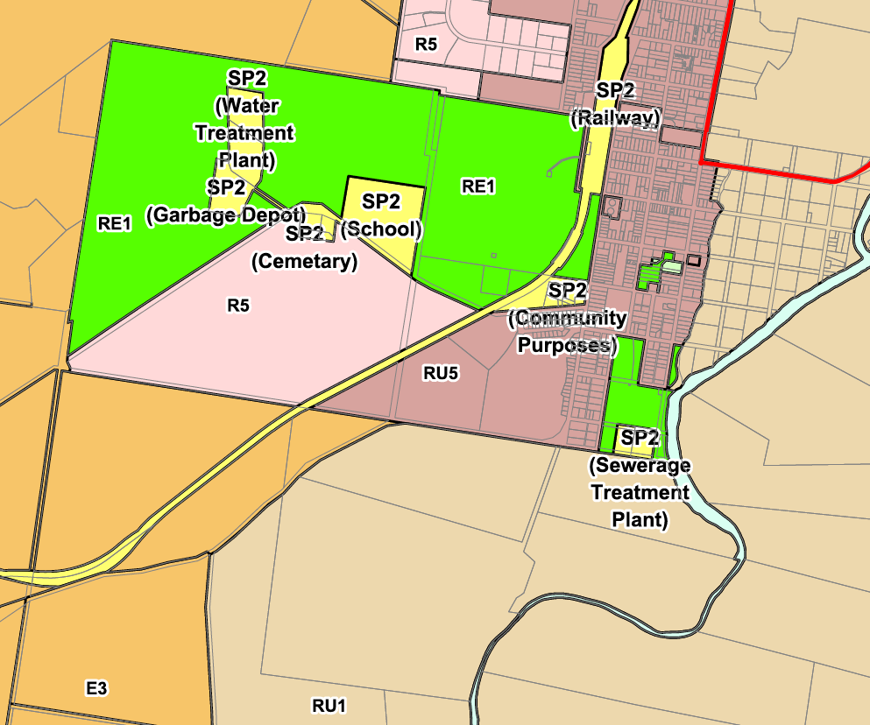

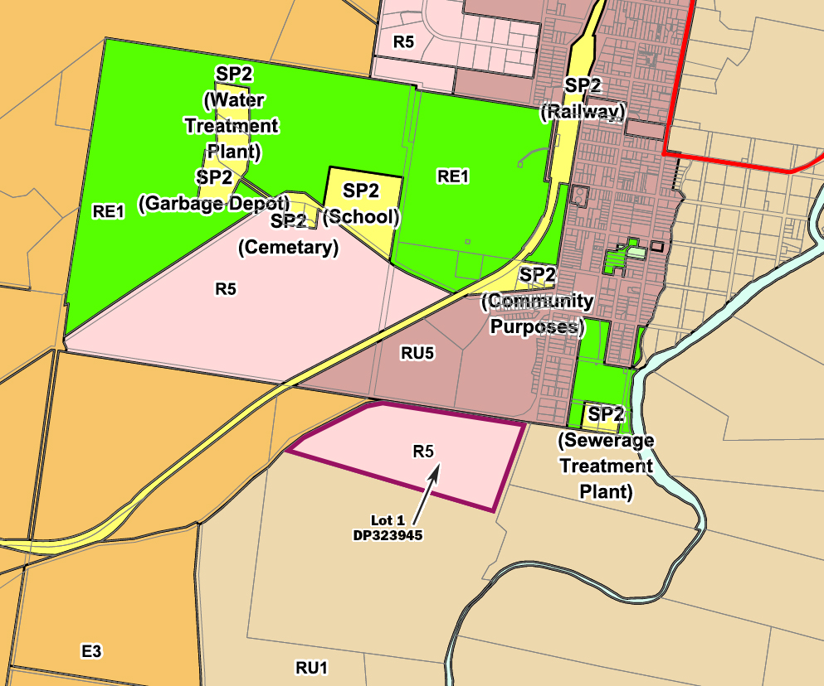***(b)*** *Proposed Land Zoning Map - Denman*

**MAP B: *Extract –* Muswellbrook LEP 2009 Lot Size Map Sheet LSZ-013**

**LOT 56**

**LOT 7**

**LOT 8**

**LOT 1**

**LOT 10**

**LOT 11**

**LOT 12**

***(a)*** *Current Lot Size Map Sheet - Denman*

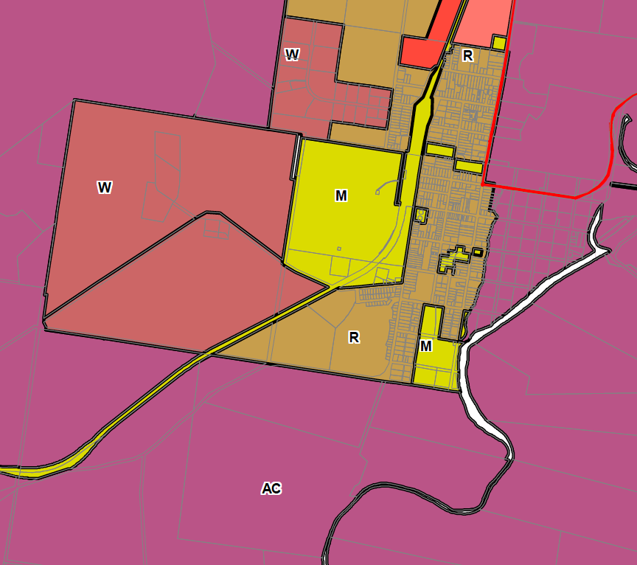

***(b)*** *Proposed Lot Size Map - Denman*

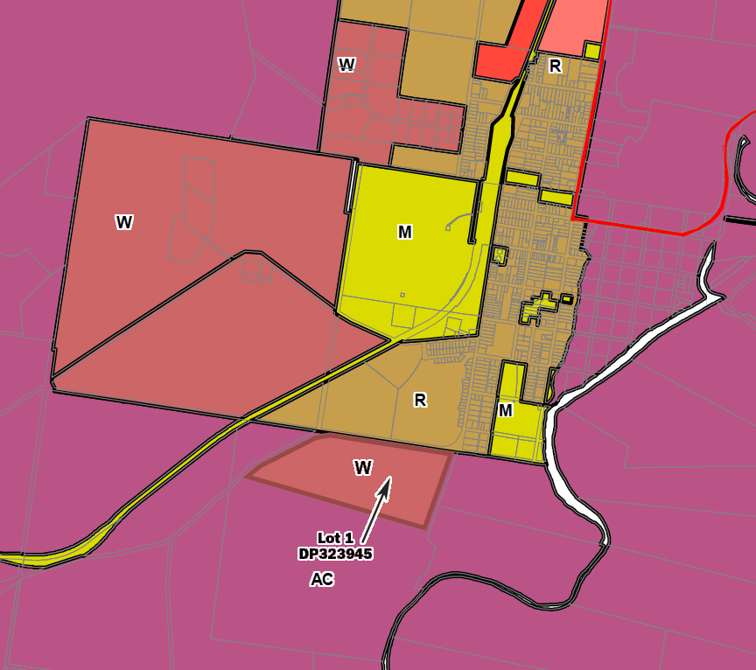

**MAP C: *Extract –* Muswellbrook LEP 2009 Height of Building Map Sheet HOB-013**

**LOT 56**

**LOT 7**

**LOT 8**

**LOT 1**

**LOT 10**

**LOT 11**

**LOT 12**

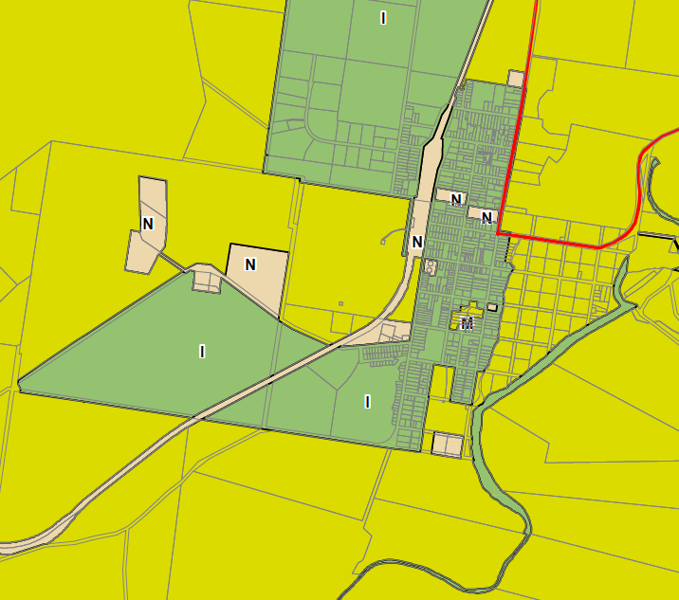***(a)*** *Current Height of Building - - Denman*

***(b)*** *Proposed Height of Building –- Denman*

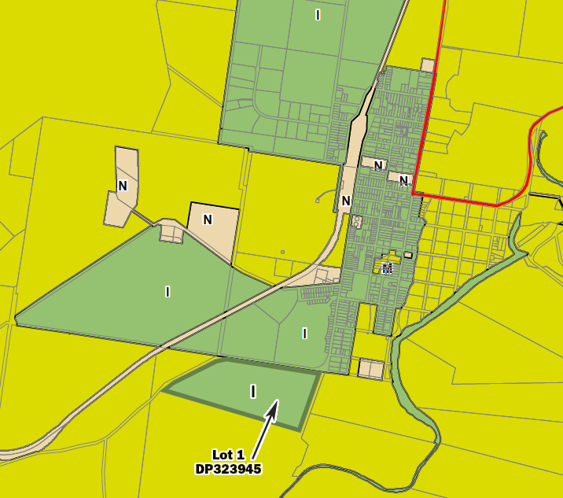

**MAP D: *Extract –* Muswellbrook LEP 2009 Urban Release Area Map (URA_005 and 005B)**

**LOT 56**

**LOT 7**

**LOT 8**

**LOT 1**

**LOT 10**

**LOT 11**

**LOT 12**

***(a)*** *Current Urban Release Area - Denman*



***(b)*** *Proposed Urban Release Area - Denman*

**3.5 Commu****nity Consultation**

The Gateway Determination dated 21 October 2014 specified that the Planning Proposal must be publically exhibited for a minimum 28 days and must comply with the section 5.5.2 of ‘*A Guide to Preparing Local Environmental Plans*’ (Department of Planning and Environment 2013).

The Planning Proposal was placed on public exhibition from 17 July 2015 to 17 August 2015. Public notices were placed in the local newspapers (Muswellbrook Chronicle, Hunter Valley News and Denman News) and on Council’s website. The Planning Proposal and supporting documents were available for available for inspection at Council’s Administration Centre and Muswellbrook and Denman libraries. Relevant public authorities and adjoining properties were notified directly.

During the public exhibition period Council received a total of four (4) submissions comprising NSW Office of Environment & Heritage, NSW Department of Primary Industries – Lands, Wanaruah Local Aboriginal Land Council and one public submission. (Submissions received from the OEH, DPI and WLALC are summarised and addressed in the Section 3.3.4). It is considered that water supply and traffic related issues raised in the public submission are matters that will be considered and addressed at the subdivision stage.

In general, the majority of the planning, design and engineering issues raised in the submissions including traffic, water supply, land use buffers, heritage are matters that may be addressed in the subdivision stage.

**3.6 Project** **Timeline**

|  |  |  |  |  |  |  |  |  |  |  |  |  |  |  |
| --- | --- | --- | --- | --- | --- | --- | --- | --- | --- | --- | --- | --- | --- | --- |
| **Task** | **Proposed timeframe** | | | | | | | | | | | | | |
| **Nov 2014** | **Dec 2014** | **Jan 2014** | **Feb 2015** | **Mar 2015** | **Apr 2015** | **May 2015** | **Jun 2015** | **Jul 2015** | **Aug 2015** | **Sept 2015** | **Oct 2015** | **Nov 2015** | **Dec 2015** |
| Issue of Gateway Determination (GD) |  |  |  |  |  |  |  |  |  |  |  |  |  |  |
| Report GD to Council |  |  |  |  |  |  |  |  |  |  |  |  |  |  |
| Completion of required further investigations in accordance with the GD and in consultation with relevant public authorities |  |  |  |  |  |  |  |  |  |  |  |  |  |  |
| Update Planning Proposal incorporating recommendations of the above investigations |  |  |  |  |  |  |  |  |  |  |  |  |  |  |
| Preparation of draft maps for exhibition |  |  |  |  |  |  |  |  |  |  |  |  |  |  |
| Report to Council for public exhibition |  |  |  |  |  |  |  |  |  |  |  |  |  |  |
| Public exhibition |  |  |  |  |  |  |  |  |  |  |  |  |  |  |
| Consultation with public authorities according to the GD |  |  |  |  |  |  |  |  |  |  |  |  |  |  |
| Review of submissions |  |  |  |  |  |  |  |  |  |  |  |  |  |  |
| Request an extension for timeframe |  |  |  |  |  |  |  |  |  |  |  |  |  |  |
| Update Planning Proposal |  |  |  |  |  |  |  |  |  |  |  |  |  |  |
| Report to Council following public exhibition |  |  |  |  |  |  |  |  |  |  |  |  |  |  |
| Submission to the Department to finalise LEP amendment |  |  |  |  |  |  |  |  |  |  |  |  |  |  |
| Gazettal of LEP Amendment |  |  |  |  |  |  |  |  |  |  |  |  |  |  |

**4 Co****nclusion**

The zoning, minimum lot size and maximum height provisions reflect consideration of environmental constraints and opportunities, surrounding land uses and built forms and suitable design outcomes that are consistent with local and regional strategies. It is recommended that this Planning Proposal, which incorporates the rezoning of Lot 1 DP 323945 from Primary Production RU1 to R5 Large Lot Residential under Muswellbrook LEP 2009, to facilitate its future development for large lot residential living purposes, be supported.

**Appendices:**

Appendix 1 – Extract: Waebron Soil and Land Capability Assessment *(attached separately)*

Appendix 2 – Gateway Determination *(attached separately)*

Appendix 3 – Submissions *(attached separately)*

Appendix 4 – Studies and Investigations *(attached separately)*

• Preliminary Aboriginal Heritage Assessment

• Preliminary Site Contamination Assessment

• Engineering Services Report

• Preliminary concept lot layout

**Appendix 1**

***Waebron Soil and Land Capability Assessment (Extract)***

*(attached separately)*

**Appendix 2**

***Gateway Determination*** *(attached separately)*

**Appendix 3**

***Submissions*** *(attached separately)*

**Appendix 4**

**4.1 Preliminary concept lot layout***(attached separately)*

* 1. **Preliminary Aboriginal Heritage Assessment** *(attached separately)*
  2. **Preliminary Site Contamination Assessment** *(attached separately)*
  3. **Engineering Services Report** *(attached separately)*